

Nama: Mohamad Maulana

Kelas: R3(C)

Nim: 210511121

Tugas 2

# Nama : Mohamad Maulana

# NIM : 210511121 # Kelas : R3/C

class Animal: def _init_(self, name, color):

self.name = name self.color = color def get_name(self): return self.name def get_color(self): return self.color

class Mammal(Animal): def _init_(self, name, color, fur): super()._init_(name, color)

self.fur = fur def get_fur(self): return self.fur

class Bird(Animal): def _init_(self, name, color, wingspan):

super()._init_(name, color) self.wingspan = wingspan def get_wingspan(self): return self.wingspan

# Hierarchical Inheritance class Reptile(Mammal): def _init_(self, name, color, fur, scale): super()._init_(name, color, fur) self.scale = scale def get_scale(self): return self.scale

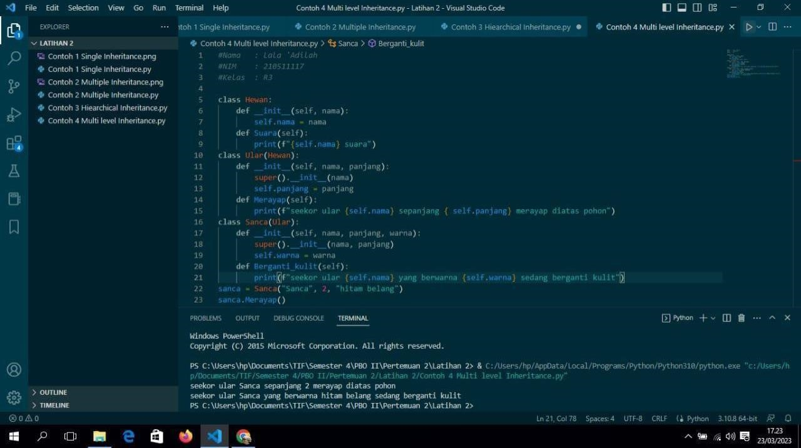

Skip to content

MohamadMaulana /

pemrograman_berorientasi_objek2

Public

Code

Issues

Pull requests

Actions

Projects

Wiki

Security

Insights Settings pemrograman_berorientasi_objek2/latihan2/contoh 1_hybrid.py

@Mohamadmaulana

Mohamadmaulana Add files via upload

1 contributor

29 lines (24 sloc) 616 Bytes

# Nama : Mohamad Maulana

# NIM : 210511121

# Kelas : R3/C

# Single Inheritance class GameObject:

def _init_(self, x, y):

self.x = x

self.y = y

# Single Inheritance class Drawable:

def draw(self):

print("Drawing object at: ", self.x, self.y)

# Single Inheritance class Moveable:

def move(self, dx, dy):

self.x += dx self.y += dy

# Multiple Inheritance class Player(GameObject, Drawable, Moveable):

def _init_(self, x, y):

super()._init_(x, y) def update(self): self.move(1, 1)

self.draw()

Footer

© 2023 GitHub, Inc.

Footer navigation

Terms

Privacy

Security

Status

Docs

Contact GitHub

Pricing

API

Training

Blog About

pemrograman_berorientasi_objek2/contoh 1_hybrid.py at main · Mohamadmaulana/pemrograman_berorientasi_objek2

Skip to content

Mohamadmaulana

/

pemrograman_berorientasi_objek2

Public

Code

Issues

Pull requests

Actions

Projects

Wiki

Security

Insights Settings pemrograman_berorientasi_objek2/latihan2/contoh 2_hybrid.py

@ Mohamadmaulana

Mohamadmaulana Add files via upload

1 contributor

48 lines (41 sloc) 1.49 KB

# Nama : Mohamad Maulana

# NIM : 210511121 # Kelas : R3/C

class Seseorang:

def _init_(self, name, age, address):

self.name = name self.age = age self.address = address

def get_info(self): print("Name:", self.name) print("Age:", self.age) print("Address:", self.address)

# Single Inheritance class Mahasiswa(Seseorang):

def _init_(self, name, age, address, student_id):

super()._init_…

Skip to content

Mohamad Maulana

/

pemrograman_berorientasi_objek2

Public

Code

Issues

Pull requests

Actions

Projects

Wiki

Security

Insights Settings pemrograman_berorientasi_objek2/latihan2/contoh 4_hierarchical.py

@Mohamadmaulana

Mohamadmaulana Add files via upload

1 contributor

34 lines (30 sloc) 918 Bytes

# Nama : Mohamad Maulana

# NIM : 210511121 # Kelas : R3/C

class Shape:

def _init_(self, name, color):

self.name = name

self.color = color def get_name(self):

return self.name def get_color(self):

return self.color

class TwoDimensional(Shape):

def _init_(self, name, color, sides):

super()._init_(name, color) self.sides = sides def get_sides(self):

return self.sides

…

# Nama : Mohamad Maulana

# NIM : 210511121

# Kelas : R3/C

# Single Inheritance class GameObject:

def _init_(self, x, y):

self.x = x

self.y = y

# Single Inheritance class Drawable:

def draw(self):

print("Drawing object at: ", self.x, self.y)

# Single Inheritance class Moveable:

def move(self, dx, dy):

self.x += dx self.y += dy

# Multiple Inheritance class Player(GameObject, Drawable, Moveable):

def _init_(self, x, y):

super()._init_(x, y) def update(self): self.move(1, 1) self.draw()

# Nama : Mohamad Maulana

# NIM : 210511121

# Kelas : R3/C

# Single Inheritance class GameObject:

def _init_(self, x, y):

self.x = x

self.y = y

# Single Inheritance class Drawable:

def draw(self):

print("Drawing object at: ", self.x, self.y)

# Single Inheritance class Moveable:

def move(self, dx, dy):

self.x += dx self.y += dy

# Multiple Inheritance class Player(GameObject, Drawable, Moveable):

def _init_(self, x, y):

super()._init_(x, y) def update(self): self.move(1, 1)

self.draw()

Skip to content

Mohamadmaulana /

pemrograman_berorientasi_objek2

Public

Code

Issues

Pull requests

Actions

Projects

Wiki

Security

Insights Settings pemrograman_berorientasi_objek2/latihan2/contoh 4_hierarchical.py

@ Mohamadmaulana

Mohamadmaulana i Add files via upload

1 contributor

34 lines (30 sloc) 918 Bytes

# Nama : Mohamad Maulana

# NIM : 210511121 # Kelas : R3/C

class Shape:

def _init_(self, name, color):

self.name = name

self.color = color def get_name(self):

return self.name def get_color(self): return self.color class TwoDimensional(Shape):

def _init_(self, name, color, sides): super()._init_(name, color) self.sides = sides def get_sides(self):

return self.sides

class ThreeDimensional(Shape):

def _init_(self, name, color, faces): super()._init_(name, color) self.faces = faces def get_faces(self):

return self.faces

# Hierarchical Inheritance class Sphere(ThreeDimensional):

def _init_(self, name, color, faces, radius): super()._init_(name, color, faces) self.radius = radius def get_radius(self):

return self.radius

Footer

© 2023 GitHub, Inc.

Footer navigation

Terms

Privacy

Security

Status

Docs

Contact GitHub

Pricing

API

Training

Blog About

pemrograman_berorientasi_objek2/contoh 4_hierarchical.py at main · Mohamadmaulana/pemrograman_berorientasi_objek2

Skip to content

Mohamadmaulana /

pemrograman_berorientasi_objek2

Public

Code

Issues

Pull requests

Actions

Projects

Wiki

Security

Insights Settings pemrograman_berorientasi_objek2/latihan2/contoh 2_hybrid.py

@Mohamadmaulana

Mohamadmaulana Add files via upload

1 contributor

48 lines (41 sloc) 1.49 KB

# Nama : Mohamad Maulana

# NIM : 210511121 # Kelas : R3/C

class Seseorang: def _init_(self, name, age, address): self.name = name

self.age = age self.address = address

def get_info(self):

print("Name:", self.name) print("Age:", self.age)

print("Address:", self.address)

# Single Inheritance class Mahasiswa(Seseorang):

def _init_(self, name, age, address, student_id):

super()._init_(name, age, address) self.student_id = student_id def get_info(self): super().get_info()

print("Student ID:", self.student_id)

# Single Inheritance class Employee(Seseorang):

def _init_(self, name, age, address, employee_id, salary):

super()._init_(name, age, address) self.employee_id = employee_id

self.salary = salary def get_info(self): super().get_info() print("Employee ID:", self.employee_id)

print("Salary:", self.salary)

# Multiple Inheritance class Penulis(Employee, Mahasiswa):

def _init_(self, name, age, address, employee_id, salary, student_id, published_books):

Employee._init_(self, name, age, address, employee_id, salary) Mahasiswa._init_(self, name, age, address, student_id) self.published_books = published_books

def get_info(self): super().get_info() print("Student ID:", self.student_id)

print("Published Books:", self.published_books)

Footer

© 2023 GitHub, Inc.

Footer navigation

Terms

Privacy

Security

Status

Docs

Contact GitHub

Pricing

API

Training

Blog About

pemrograman_berorientasi_objek2/contoh 2_hybrid.py at main ·

Mohamadmaulana/pemrograman_berorientasi_objek2

